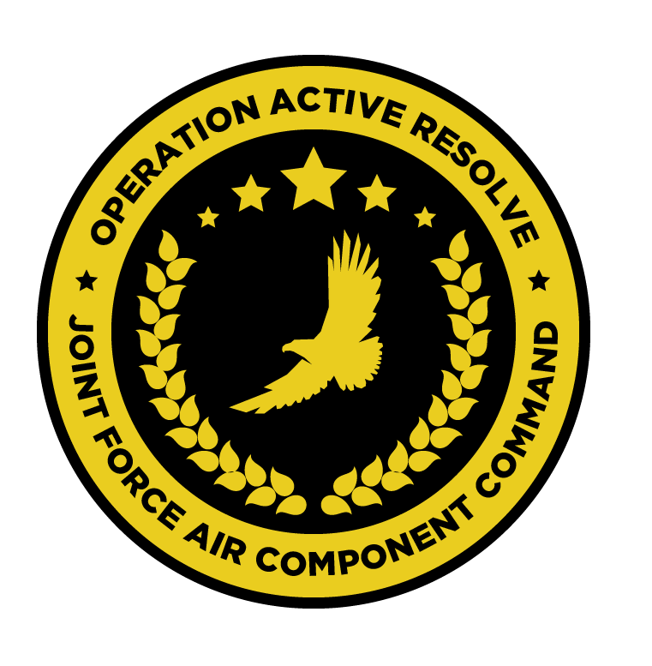

JFACC AIR OPERATIONS DIRECTIVE

OPERATION ACTIVE RESOLVE

D+5

# 1. SITUATION

## a. JFC guidance (verbatim).

See [CJTF Operations Order](https://132nd-vwing.github.io/OPAR-Brief/ORDERS/OPAR%20CJTF82%20OPERATION%20ORDER.pdf) and [CJTF Directions & Guidance D+5](https://132nd-vwing.github.io/OPAR-Brief/MISSION%20INFORMATION/CJTF_D_G/OPAR%20CJTF%20DIRECTION%20AND%20GUIDANCE%20D5.pdf)

## b. Enemy situation.

[VIS INTSUM GROUND](https://132nd-vwing.github.io/OPAR-Brief/INTELLIGENCE/INTSUM/VIS_INTSUM_D4_Ground.pdf), [VIS INTSUM AIR](https://132nd-vwing.github.io/OPAR-Brief/INTELLIGENCE/INTSUM/VIS_INTSUM_D4_AIR.pdf), [VIS INTSUM IADS](https://132nd-vwing.github.io/OPAR-Brief/INTELLIGENCE/INTSUM/VIS_INTSUM_D4_IADS.pdf), [VID INTREP D+4](https://132nd-vwing.github.io/OPAR-Brief/INTELLIGENCE/VID/OPAR_VID_INTREP_D4.pdf)

## c. Friendly situation (by joint force component).

See [CJTF Operations Order](https://132nd-vwing.github.io/OPAR-Brief/ORDERS/OPAR%20CJTF82%20OPERATION%20ORDER.pdf) and [LCC III Corps Conops](https://132nd-vwing.github.io/OPAR-Brief/ORDERS/OPAR%20LCC%20III%20CORPS%20CONCEPT%20OF%20OPERATIONS%20PHASE%201.pdf) and [LCC IV Corps Conops](https://132nd-vwing.github.io/OPAR-Brief/ORDERS/OPAR%20LCC%20IV%20CORPS%20CONCEPT%20OF%20OPERATIONS%20PHASE%201.pdf) and [CJTF Directions & Guidance D+5](https://132nd-vwing.github.io/OPAR-Brief/MISSION%20INFORMATION/CJTF_D_G/OPAR%20CJTF%20DIRECTION%20AND%20GUIDANCE%20D5.pdf)

# 2. MISSION - The JFACC’s mission statement (verbatim).

JFACC will establish air superiority in the area of operations and defeat Syrian offensive capability in support of CJTF-82 offensive operations to neutralize Syrian offensive capability to conduct offensives in the region.

# 3. EXECUTION – AIR OPERATIONS

|  |  |
| --- | --- |
| **JFACC’s Intent**   1. **Purpose** 2. **End State** | JFACC intends to continue to deny the enemy the use of the air, by conducting a targeted strike at Jirah Airbase, where intelligence suggests that many Quick Reaction Alert flights are launched from.  Additionally, resources will be directed to undertake an intelligence led strike, aimed at destroying SCUD and MLRS units located at Abu Al-Duhur.  Finally, support will continue to be provided to those ground units operating in Sector NORTH, including a request for assistance from JTAC WARRIOR.  Excess sorties may be allocated to the attrition of resources in Sector SOUTH as outlined later in this document.  The purpose of such operations is two-fold:   * To ensure the safe operation of friendly air forces * To provide direct support to friendly ground forces by attempting to attrit enemy ground forces.   The desired end state of today’s operations is such that:   * Friendly air forces can attrit enemy ground forces with greater relative safety in future combat sorties, including strikes against fixed assets. * Enemy ground forces in Sector NORTH are significantly impacted in their ability to fight * Syrian forces are denied an amount of their long range attack capabilities. |
| **Execution** | In the execution of these missions, the AO is divided into two sectors – Sector NORTH and Sector SOUTH. These sectors are divided by the Bullseye 090 degree radial.  Operations are to be conducted at the FLOT in both Sectors NORTH and SOUTH, in addition to deliberate action in Sector NORTH. |
| **Focus of effort by objective** | Three areas of focus are addressed in this AOD:  **Sector NORTH**  In this sector, the majority of effort should be focused on supported Air Interdiction strikes against OPARTGT039 – Jirah Airbase. In addition, supporting effort will attempt to destroy strategic objectives located at Abu Al-Duhur.  Effort should also be directed to the attrition of the enemy 11th Mechanised Division and 10th Armoured division to inhibit their advance into Turkish territory.  **Sector SOUTH**  There are no planned sorties for Sector SOUTH. |
| **Allocation of sorties** | AI – 45%  DEAD/SEAD – 25%  ESCORT - 10  DCA – 15%  CAS – 5% |
| **Acceptable level of risk**. | For deliberate action against OPARTGT039, HIGH risk is considered acceptable.  For all other sorties, MEDIUM risk is considered acceptable. |
| **Collateral damage and civilian casualty guidance** | Every attempt should be taken to minimise collateral damage in the execution of these missions. Aircrew should act in accordance with the [Law of Armed Conflict](https://www.doctrine.af.mil/Portals/61/documents/Annex_3-60/3-60-D33-Target-LOAC.pdf) at all times  Suspected civilian casualties should be reported through the C2 network as soon as is practicable. |
| **TST guidance** | Refer to SPINS/JPTL. |
| **Intelligence, Surveillance, Reconnaissance (ISR)** | All notifications of enemy air defence assets – ground- and air-based – must be reported as soon as is practicable. Reports should, where possible, include the observing aircraft’s currently position, a relative bearing to the threat and the type of threat.  Sensor taskings should be conducted where resources permit to identify the location and movements of enemy air defence assets and SCUD launchers/WMD. These locations should be reported as soon as is practicable.  Where possible, ELINT activities should be conducted to identify the locations of SAM threats. |
| **Other issues** | NSTR |
| **Direction and Guidance** | Aircrews **must** remain clear of Jordanian and Lebanese airspace at all times. Munitions must not be expended which may encroach on either airspace. |

# 4. ADMINISTRATION AND LOGISTICS

NSTR

# 5. COMMAND AND CONTROL

NSTR